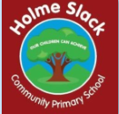

Progression in mapping

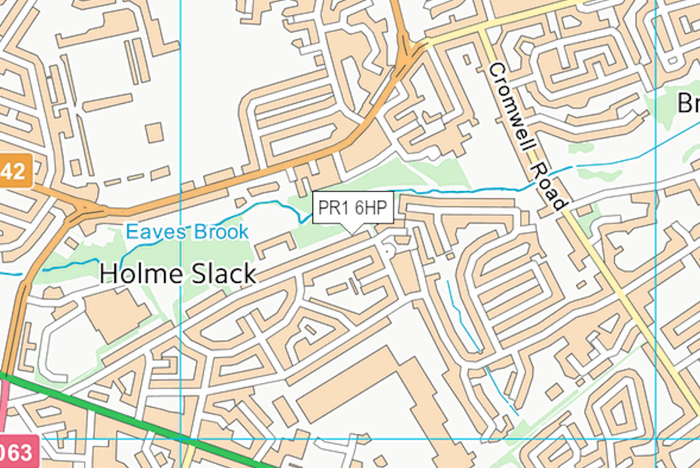
Geography Teaching Resource
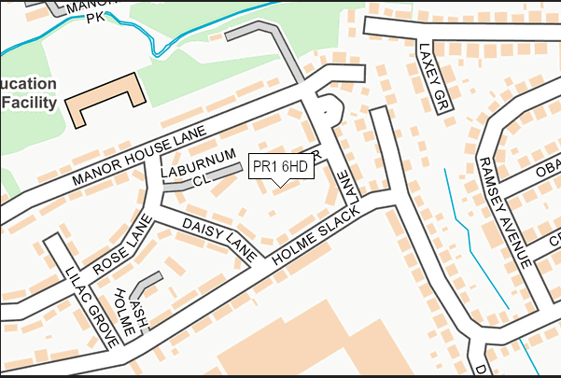

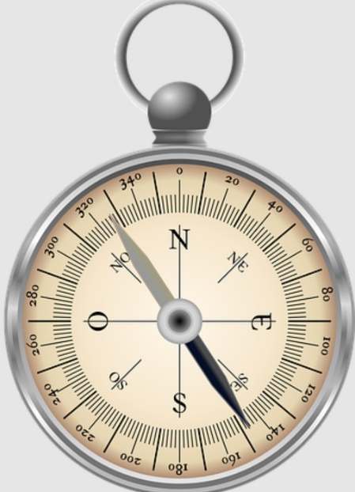

Years 1 and 2
Using and interpreting | Position and orientation | Drawing | Symbols | Perspective and scale | Digital map making
I can find information on aerial photographs.  I know that maps give information about the world (where and what?).  I can follow a route on a prepared map.  I can recognise simple features on maps such as buildings, roads and fields.  I recognise that maps need a title.  I can use maps to talk about everyday life for example, where I live, journey to school, where places are in a locality.  I can begin explaining why places are where they are. | I am beginning to use directional vocabulary.  I can say which direction N, S, E,W is for example, using a compass in the playground.  I know which direction N is on an Ordnance Survey map. | I can draw a simple map  (real or imaginary place) for example, freehand maps of gardens, watery places, route maps, places in stories. | I can use symbols on maps (own and class agreed symbols).  I know that symbols mean something on maps.  I can find a given Ordnance Survey symbol on a map with support.  I am beginning to realise why maps need a key. | I can look down on objects and make a plan for example, on desk, high window to playground.  I can draw objects to scale (for example, on table or tray using squared paper 1:1 first, then 1:2 and so on).  I can use large scale, vertical aerial photographs.  I know that when you ‘zoom in’ you see a smaller area in more detail. | I can find places using a postcode or simple name search.  I can add simple information to maps for example, labels and markers.  I can draw around simple shapes and explain what they are on the map for example, houses.  I can use the measuring tool with support to show distance for example, my house to school, to the shops.  I can zoom in and out of a map.  I can draw a simple route.  I can highlight areas.  I can add an image to a map.
Work confidently with:  - Large scale street maps and large scale  - Ordnance Survey maps (1:1250. 1:2500)  - Aerial photographs  - Games with maps and globes.  Have experience of:  - a range of different maps for example, tourist brochure, paper maps, storybook maps,  - Ordnance Survey digital maps at different scales,  - globes and atlases.  Introduce:  - simple grids,  - four cardinal points,  - basic digital mapping tools,  - zoom function of digital maps.  Context:  - focus on the local scale - home, school, neighbourhood, everyday lives (their own and others), work in the school grounds.  - global scale – world maps, globes and through story. |  |  | Suggested Digimap for Schools Activities  - Letter to our school  - Where do I live?  - How can we get to Grandma’s safely?  - What’s the quickest way to school?  - My geography glasses  - Who goes to school by boat?  - Where does our milk come from?  - Where do I go in a week?  - Capital Stops  - My Dream Island  - The Magic Telescope

Years 3 and 4
Using and interpreting | Position and orientation | Drawing | Symbols | Perspective and scale | Digital map making
I can use atlases, maps and globes.  I can use large scale maps outside.  I can use maps at more than one scale.  I can make and use simple route maps.  I can locate photos of features on maps.  I can use oblique and aerial views.  I can recognise some patterns on maps and begin to explain what they show.  I can give maps a title to show their purpose.  I can use thematic maps.  I can explain what places are like using maps at a local scale.  I recognise that contours show height and slope. | I can use simple grids.  I can give direction instructions up to 8 cardinal points.  I can use 4-figure coordinates to locate features.  I know that 6 figure Grid References can help you find a place more accurately than 4- figure coordinates. | I can make a map of a short route with features in correct order.  I can make a map of small area with features in correct places. | I can use plan views regularly.  I can give maps a key with standard symbols.  I can use some Ordnance Survey style symbols. | I can use maps and aerial views to help me talk about for example, views from high places.  I can make a simple scale plan of room with whole numbers for example, 1 sq.cm = 1 square tile on the floor moving onto 1cm2 = 1m2.  I can use the scale bar to estimate distance.  I can use the scale bar to calculate some distances.  I can relate measurement on maps to outdoors (using paces or tape). | I can use the zoom function to locate places.  I can use the zoom function to explore places at different scales.  I can add a range of annotation labels and text to help me explain features and places.  I can highlight an area on a map and measure it using the Area Measurement Tool.  I can use grid references in the search function.  I can use the grid reference tool to record a location.  I can highlight areas within a given radius.  I can add photographs to specific locations.
Work confidently with:  - Large scale street maps and large-scale Ordnance Survey maps (1:1250, 1:2500),  - aerial photographs,  - oblique and bird’s eye views,  - games with maps and globes,  - Ordnance Survey maps 1:1250, 1:2500 and 1:10 000,  - 4-figure coordinates.  Have experience of:  - a range of different maps for example, tourist brochure, paper and digital maps, storybook maps, atlases, Ordnance Survey paper and digital maps at different scales,  - 6-figure coordinates.  Introduce:  - what 6-figure Grid References mean,  - 8 cardinal points,  - greater independence in using digital mapping tools.  Context:  a range of places in the wider locality and in contrasting localities, fieldwork in the wider locality. |  |  | Suggested Digimap for Schools Activities  - Treasure Hunt  - Picture Detectives  - Artful Maps  - Patterns of land use  - Flying High: White –Tailed Eagles  - Teifi Travels  - A Taste of Scotland  - Landscape Fingerprints

Years 5 and 6
Using and interpreting | Position and orientation | Drawing |  | Symbols | Perspective and scale | Digital map making
I can relate maps to each other and to vertical aerial photographs.  I can follow routes on maps saying what is seen.  I can use index and contents page of atlas.  I can use thematic maps for specific purposes.  I know that purpose, scale, symbols and style are related.  I can appreciate different map projections.  I can interpret distribution maps and use thematic maps for information  I can follow a route on 1:50 000 Ordnance Survey map; I can describe and interpret relief features. | I can use 4 and 6-figure coordinates to locate features.  I can give directions and instructions to 8 cardinal points.  I can align a map with a route.  I can use latitude and longitude in an atlas or globe. | I can make sketch maps of an area using symbols and key.  I can make a plan for example, garden, play park; with scale.  I can design maps from descriptions.  I can draw thematic maps for example, local open spaces.  I can draw scale plans. |  | I can use agreed and Ordnance Survey symbols.  I appreciate maps cannot show everything.  I can use standard symbols  I know 1:50.000 symbols and atlas symbols. | I can use a range of viewpoints up to satellite.  I can use models and maps to talk about contours and slope.  I can use a scale bar on all maps.  I can use a linear scale to measure rivers.  I can describe height and slope using maps, fieldwork and photographs.  I can read and compare map scales.  I can draw measured plans for example, from field data. | I can find 6-figure grid references and check using the Grid Reference Tool.  I can combine area and point markers to illustrate a theme.  I can use maps at different scales to illustrate a story or issue.  I can use maps to research factual information about locations and features.  I can use linear and area measuring tools accurately.
Work confidently with:  Large scale street maps and large-scale Ordnance Survey maps (1:1250. 1:2500); aerial photographs, oblique and bird’s eye views, games with maps and globes, Ordnance Survey maps 1:1250, 1:2500,1:10 000, 1:25 000. 1:50 000 4 and 6-figure coordinates.  Have experience:  of a range of different maps for example, tourist brochure, paper and digital maps, storybook maps, atlases, Ordnance Survey paper and digital maps at different scales, 6-figure coordinates.  Introduce: what 6 figure Grid References mean and how to calculate them.  Context: a range of places at different scales and with different themes, fieldwork in the wider and distant locality. |  |  | Suggested Digimap for Schools Activities  - Fantasy Maps  - Weather Warning!  - Coastal Mysteries  - Landscape Poetry  - Lighthouse for Sale  - My Top Tourism Trail  - It’s a Rubbish Footprint!  - Extreme GB  - Map Detectives  - Emergency Rescue!

See also
- Mapping our Globe http://www.geography.org.uk/resources/mappingourglobe/#top
- Think pieces and Resources Making Maps http://www.geography.org.uk/gtip/thinkpieces/makingmaps/#786

Copyright
©EDINA at the University of Edinburgh 2016
This work is licensed under a Creative Commons Attribution-Non-Commercial Licence 

