

Forest School Handbook
2024/2025

Contents
What is Forest School? | 3
Our Forest School Philosophy & Aims | 3
Where will Forest School Take Place | 4
Good Practice | 4
Country6side Code | 5
Daily Operating procedure | 6
Session Outline | 7
Session Activity Suggestions | 7
Collecting Materials | 7
Cancellation of Sessions | 7
Toileting Procedures | 8
Tool Talks | 8
Bowsaw TT | 9
Billhook TT | 10
Hand Drill TT | 11
Bush Craft Knife TT | 12
Tool Maintenance | 13
Forest School Staffing | 14
Medical Emergency | 14
First Aid | 15
Serious Injury to pupils/staff | 15
Policies & Procedures | 16
Staff & Volunteer Responsibility | 16
Safeguarding | 16
Missing Child | 16
Boundaries | 17
Behaviour Policy | 17
Fire Procedure | 18
Clothing Policy | 18
Site Hazards | 19
Adverse Weather | 19
Food Hygiene | 20
Parent / Guardian Consent | 20
Risk Assessments | 20
General Forest School RA | 21
Temporary Shelter Building RA | 24
Environmental Art RA | 25
Fire Lighting & Cooking RA | 26
Hammock & Tyre Swing RA | 28
Mini Beast Hunting RA | 30
Tool Use RA | 32
Tree Climbing RA | 34
Traversing climbing Wall RA | 35
Ecological Impact Assessment | 36
Appendices Public Liability | 37
Site sweep Form | 38
Parental Consent Letter | 39
Food Hygiene Certificate | 40
Outdoor First Aid Certificate | 41
Forest School Level 3 Certificate | 42

What is Forest School?
The forest school association describe forest school as ‘an inspirational Process’ one of which is inclusive of ‘All learners’ providing ‘regular opportunities to achieve and develop confidence and self-esteem through hands-on learning experiences in a woodland or natural environment with trees.
This forest school ethos is worldwide and practitioners run their sessions on 6 key principles:
FS is a long-term process of regular sessions, rather than a one-off or infrequent visit; the cycle of planning, observation, adaptation and review links each session.
FS takes place in a woodland or natural environment to support the development of a relationship between the learner and the natural world.
FS uses a range of learner-centred processes to create a community for being, development and learning.
FS aims to promote the holistic development of all those involved, fostering resilient, confident, independent and creative learners.
FS offers learners the opportunity to take supported risks appropriate to the environment and to themselves.
FS is run by qualified Forest School practitioners who continuously maintain and develop their professional practice
(Summarised from The Forest School association website)

Our Forest School Philosophy & Aims
Holme Slack CP School has decided to provide our learners with the Forest School experience to ensure our pupils are given opportunities to Achieve. We recognise the classroom doesn’t always provide the environment for everybody’s self-esteem to flourish to its full potential. We aim to provide opportunities for our learners to:
Be inspired to lead their own learning
Be curious, develop imagination and take risks
To learn about their environment
To take care of their environment
Give them freedom within a safe area to explore and simply ‘be children’ away from electronic devices.

Where will Forest School take place?
Sessions are to take place on Holme Slack’s school grounds. Behind school and to the righthand side we have acquired a wooded area for the sole purpose of providing a setting for our Forest School Seasons. The site is accessed from within school grounds.
It has a fire pit and seating circle and a shade sale area. The space does have a pond /bog area depending on the weather and rainfall levels, this is fully fenced off. It does not have any running water or electrical supply, nor does it have a toilet facility. The site is home to various tree species. The fire pit has a parachute for use at any time.

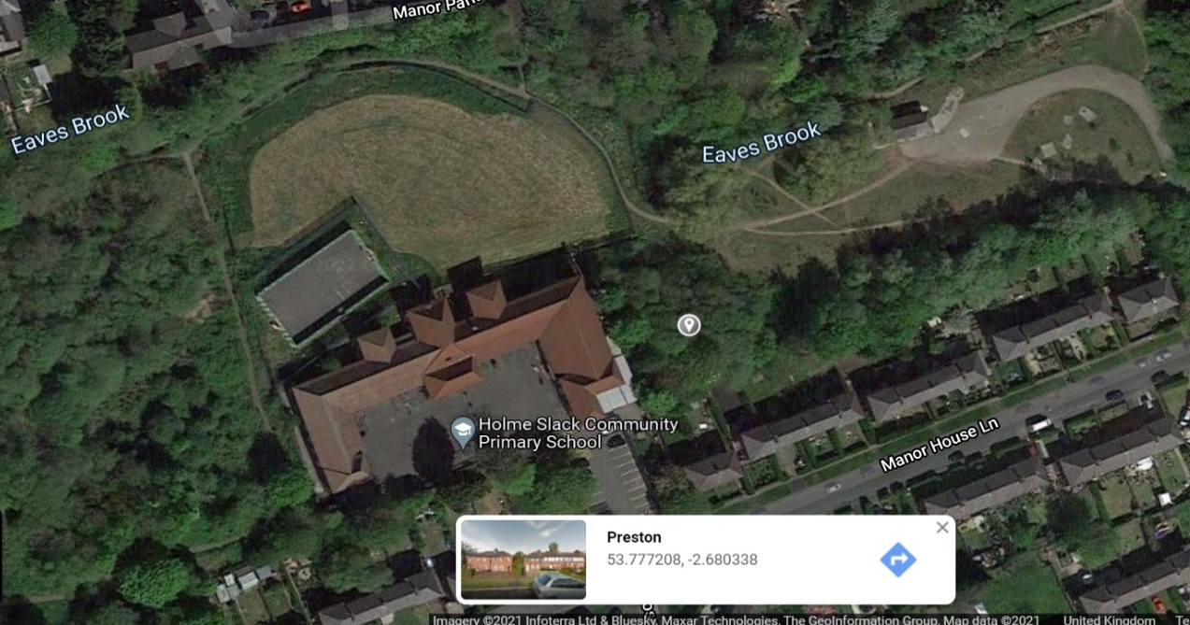
Holme Slack CP School
Manor House Lane
Preston,
PR1 6HP

What 3 Words
Carpark:
Nights.elbow.turkey
Firepit:
Visits.fade.tasty

Good Practice
Entering and leaving the woodland
We will arrive via the back of school, we will walk round from the junior playground round the left-hand side of school, past the MUGA and school field. As we walk we will be using this time to tune in to the natural environment, listening to what is surrounding us. We will begin sessions within ‘The Echo’ covered space to ensure all learners have the appropriate clothing and we get any equipment required from the storage there.
We will ‘leave no trace’. Any shelters we make will be dismantled, unless agreed.
We will take all equipment back to ‘The Echo’ and within there, learners can change out of wet dirty clothing into their dry clothes. Items made on site can be taken home by learners.
Reporting damage or problems
Any damage or issues requires reporting to The School Business Manager within the school office within a timely manor.

Countryside Code
The children will be fully involved in making decisions on what the sessions are to include and shaping what they do in the forest.
The children will be briefed on the county side code and expected to adhere to it, along with staff. The code is summarised as follows:
Respect – Children will be asked to consider the local community.
This is extended within Holme Slack’s Forest School rules to include respect of their peers, their ideas and creations. Verbal or physical abuse towards others will not be tolerated and will result in exclusion from sessions.
Protect – We want to build a love of the outdoors with our children and thus protecting our environment is paramount to their enjoyment for them and future generations. Taking only pictures and leaving only footprints.
Enjoy – Enjoyment of the outdoors comes with preparation – ensuring we have the correct clothing and checked for adverse weather etc.

Along with the countryside code the learners will have Forest School rules to adhere to:

Boundaries – Children are required to stay within the boundaries of the forest school areas at all times. They will be made aware of these boundaries before the session starts.

Eating – Only food and drink provided by the forest school leader will be allowed to be consumed. Wild fruit / fungi that is found growing is not to be consumed at all. Children will be informed and reminded of this regularly. Discussions regarding what they have found and identification of this will be encouraged.

Awareness – Children are required to be alert at all times, as they are within a woodland there are hazards to be aware of. There will be risk assessments in place for each activity however children are encouraged to assess risk themselves by using their senses, looking where they are going at all times, and listening for call backs and to safety instructions.

Daily Operating Procedure
Each session will be different, however, required, is a general outline of what is required from the Forest School leader and adults as delegated before, during and after each session, to ensure the safety of the both children and staff.
Travel to site
Done Via foot from the learners classrooms.
Before the session commences
Ensure all learners have appropriate clothing for the weather.
Ensure all equipment is available and ready for the session to run safely.
Site sweep form to be completed before all sessions (Page 38).
Ensure staffing ratios are adhered to.
Check weather forecast.
Upon collecting the learners from their class the Forest School leader will ensure they lead the group down to the woodland area, continually assessing risk and noting any hazards.
During the session
Continually assessing risk.
Leading the sessions in line with the session outline.
Lead the sessions following Forest School training and the 6 principles.
Adults are evenly distrusted around the site.
After the session
Site sweep to ensure no trace left.
Assessing how it went and using the learners input to shape the next session.
Return all resources to the designated storage within ‘The Echo’ – Clean tools.
Follow up any incidents and complete relevant paper work.

Session Outline
Every session will be moulded by the learners and what they want to pursue their interest in.
However, the sessions will follow the informal guideline:
- Arrive at the Echo
- Change into appropriate kit
- Walk to fire circle
- Check in and safety talk around circle with a reminder about call back (Sticky Feet)
- Recap anything needed from previous week
- Introduce any experiences for the session/ anything else of importance that children need to know
- Play warm up game
- Sticky Feet gathering (head count)
- Complete a short directed activity
- Wash hands & optional Snack & Drink
- Learner – Led exploration
- Sticky Feet gathering (head Count)
- Review session
- Extinguish fire if appropriate
- Pack equipment away
- Walk back to Echo to change
- Return to school
Session activity suggestions
Shelter building • Fire lighting • Tool use • Studying wildlife • Playing team and group games • Sensory activities • Tracking games • Cooking on an open fire • Using a Kelly Kettle • Rope and string work • Art and sculpture work • Woodland and traditional craft • Developing stories and drama, and meeting imaginary characters • Physical movement activities
Collecting Materials
Making items from natural materials requires the learners to search for their resources. Nothing living will be picked. Berries and Mushrooms will not be touched or eaten. A strict no eating rule will be in place, unless it is food provided by the Forest School leader around the fire.
Cancellation of Sessions
Factors that could cause a cancelled session may include:
Staffing shortage (adhere to staffing ratios)
Adverse weather (see policy)
Damage to site (risk assessments and site sweeps)

Toileting Procedure
Children will be encouraged to go to the toilet before leaving the school building.
On site there is not a toilet. If a learner requires the toilet they will be escorted back up to the school building, if learner is able to go themselves, they can do so. Adult permission is required.
Tool Use

Holme Slack aim to provide as full of a Forest School experience as we can for the learners. Where appropriate tool use will be encouraged.
The age, development and behaviour of the learners will all be taken into consideration before the agreement to introduce tools will be made.
The following tools are recommended for use at Forest schools. They are accompanied with a ‘tool talk’ which must be completed before the use of each tool.
A risk assessment for tool use is included on page 32 with relevant steps to take to minimise risk, ratios for tool use and risk benefits.

Procedure for Safe use and handling of a Bowsaw
Tool and safety talk
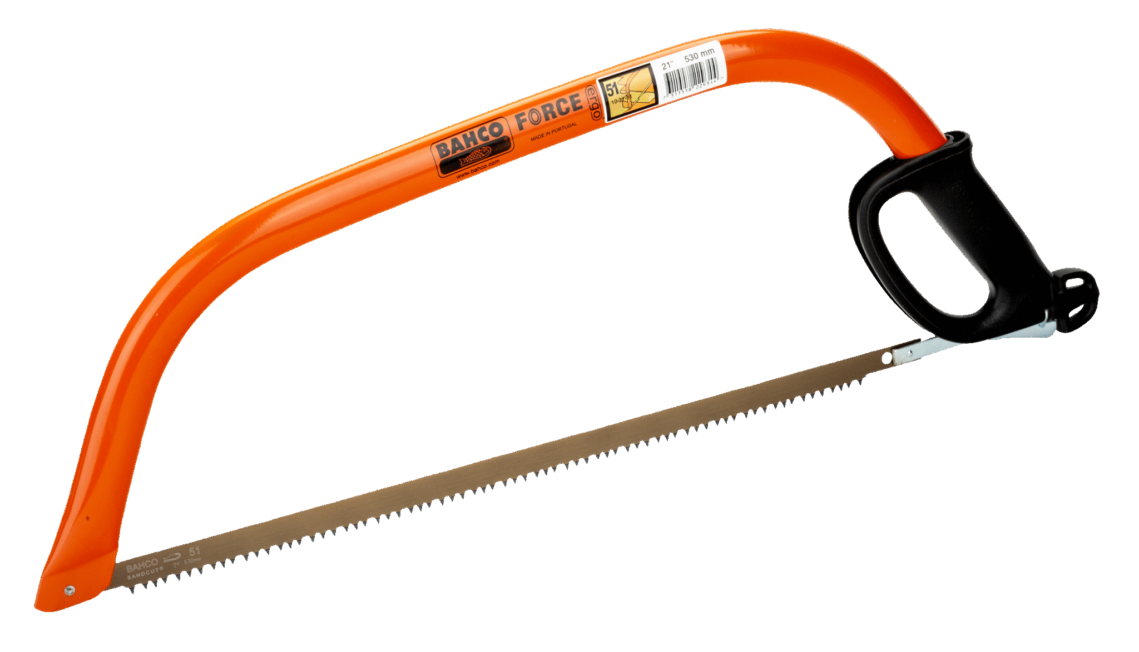

This is a Bowsaw.
This is the handle.
This is the blade. (M blade used – suitable for cutting both green wood and dead wood)
This is the blade Cover.
I take the cover off like this.
This is the cutting edge.
When I have finished sawing I put the blade cover back on like this.
I hold the bowsaw like this.
When I am not using the bowsaw I place it down with the blade facing away from me.
I pass the bowsaw like this.
When I am not using the bow saw I put it down with the blade facing away and the handle facing in like this.
I use the bowsaw to cut anything bigger than a 2 pence piece.
When I use the bowsaw I use it two arms and a tool away like this.
When I have finished using the bowsaw I put it away in the designated tool area/storage box.
I always use a rigger glove on my helping hand.

Procedure for Safe use and handling of a Billhook
Tool and safety talk
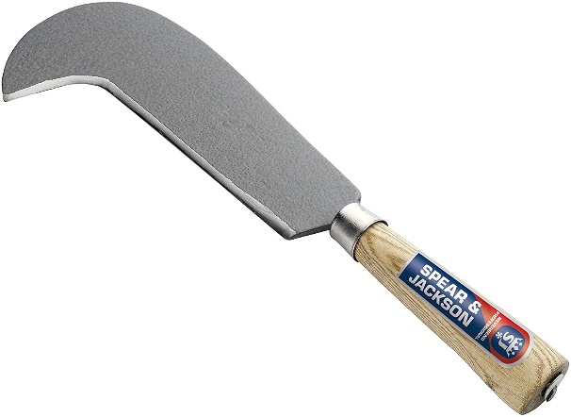

This is a Billhook.
This is the cover/sheath.
This is the handle.
This is the blade.
This is the cutting edge.
I hold the billhook like this.
I walk with the billhook like this.
I pass the billhook like this.
When I am not using the billhook I put it on top of the cover with the blade facing out and the handle facing forward.
I use the billhook to cleave (split) wood.
When I use the billhook I use it 2 arms and a tool away from anyone else like this.
When I have finished using the billhook I put it away in the designated tool area/ storage box.
I always use a rigger glove on my helping hand.

Procedure for Safe use and handling of a Hand Drill
Tool and safety talk
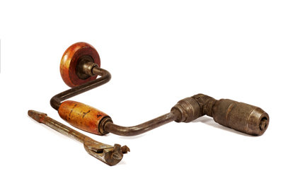

This is a hand drill.
This is the handle.
This is the knob.
This is the u-shape crank.
This is the ratchet.
This is the chuck.
I hold the hand drill like this with the drill bit facing downwards.
I pass the drill holding the handle and the drill bit facing down.
I use the hand drill to make holes in wood.
When I use the hand drill I use it 2 arms and a tool away from anyone else like this.
When I have finished using the hand drill I put it back in the designated tool area / storage box.
I do not need to use a rigger glove as both hands are on the drill.
If a partner is helping to hold the wood they must wear rigger gloves on both hands.

Procedure for Safe use and handling of a Bush craft Knife
Tool and safety talk
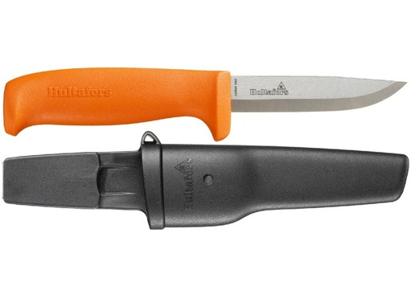

This is a bush craft knife.
This is the sheath.
This is the handle.
This is the blade.
This is the cutting edge.
I hold the bush craft knife like this with a pistol grip and my thumb facing down.
To transport the knife, I keep it in the sheath on a lanyard and wear it around my neck.
I pass the knife within the sheath on the lanyard.
I use the knife to split wood, whittle wood and carve wood.
When I use the bush craft knife I use it 2 arms and a tool away from anyone else like this.
When I have finished using the bush craft knife I put it back in the sheath and take it straight to the designated tool area and lock it within the designated knife storage box.
I use a rigger glove on my helper hand to remove the knife from the sheath with the blade facing upwards.
To split wood, I use a mallet in front of my body at arm’s length. No rigger gloves needed.
To carve or whittle wood I use the tool at the side of my body with the wood across my body. I rest the wood I am carving on top of another piece of wood. I push the knife down and away. I wear a rigger glove on my helping hand.

Tool | How to Check | How to Clean | How to maintain | How to Store
Bow Saw | -Make sure Handle is secure – check the pins  -Check frame for stability and ensure it isn’t bent | -Wipe with oily rang to get off sap on the back of the blade using 3 in 1 oil. | -Clean after each use  -Ensure blade cover is always on when not in use  -Replace blade if rusty/bent or blunt (Forest school leader able to do this using the mechanism on the saw to easily replace) | -Ensure blade cover is on  -Dry, locked, storage.
Bushcraft knife | -Check blade for any nicks  -Check the handle and blade are securely in place not loose. | -Wire wool on both sides of blade with metal polish  -3 in 1 oil on a wet stone, rough side first, following a rainbow motion, flat but with a tipped blade on the bevelled edge, working away from yourself across the stone, 10 times, placing pressure on the blade throughout.  - Then turn over and repeat on smooth side, adding oil to the stone again. Swopping hands if required.  - Use a leather strop pad to remove any filings from the blade | - Ensure cleaning is evenly done as not to wear down the blade unevenly. | -Ensure Cover is on  -Dry, Locked, labelled knife box.
Billhook | -Ensure the handle and blade are solid and not loose  - Check for dents on the blade | -Metal polish on to the blade – wire wool in a circular motion  -Wipe excess off with an oily rag  -Cigar stone to sharpen the bevelled edge on both sides.  At least 10x in a downwards motion sweeping away from the body.  -Replicate this on the other bevelled edge side, swopping hands if required. | - Replace into sheaths | Dry, Locked Storage
Loppers | -Check the handles, ensure they are secure and not loose.  -Check all nuts and bolts are secure | - Apply metal polish directly onto the blade and use wire wool to cover.  -Cigar stone to sharpen the blade, 10x downwards sweeping motion along the bevelled edge  -Repeat at the other side. | -WD40 any joints that are tight / squeaky  -Repeat the sharpening process if required to increase productivity of the blade. | Dry, Locked storage
Secateurs | -Ensure the lockable fastener is in working order  -Check for nicks  -Check handles | -Dab on metal polish and use wire wool to clean.  - Sharpen the bevelled edge with a diamond file (smaller than a cigar stone) or a cigar stone will suffice.  -Wipe clean with oily rag |  | Dry, Locked Storage
Potato Peeler | -Secure blade on the handle  - No bent / blunt blade | -Hot soapy water |  | Dry, Locked Storage
Tool Maintenance

Forest School Staffing
Mrs Helen Lenz (Forest School Level 3 trained)
Holme Slack Forest School is staffed by 2 adult minimum. The size of group partaking will be up to 30 children at any one time.
They will take part in a Forest School session once a week, for 1 hour.

Medical Emergency
The nearest A & E is:
Royal Preston Hospital, Tel: 01772 716565
Sharoe Green Lane,
Fulwood,
Preston,
PR2 9HT.
In emergency call 999.
What 3 Word Location @ Holme Slack School car park: nights.elbow.turkey.
What 3 Word location @ fire pit: visits.fade.tasty.
Medical Emergencies
Parents / guardians will have completed medical forms for their children at school and any medical issue will be known prior to attending the Forest School Sessions.
These forms include up to date medical information and emergency contact details for the child.
Every person involved within Forest School must have a medical form, including children, staff and volunteers. (These will have been completed when child / staff member joined the school)
The Forest School Walkie Talkie will be within the emergency bag.
The emergency procedure for serious injury to pupil / staff is covered further down.

First Aid
Named First Aider: Mrs Helen Lenz
Outdoor First Aid Trained /Paediatric First Aid Qualification
Contents for emergency / First Aid kit / Burns Kit
The kit needs to be regularly checked and re-stocked. An iPad can be brought down to ‘The Echo’ and the link to the first aid form with this to ensure the timely and accurate recording of any first aid delivered, however depending on signal to the internet the form may have to be completed once back up at school.
If a fire is being lit then a burns kit is required to be on site at all times the fire is lit. Water containers required for extinguishing the fire.
In case of an emergency the Forest School handbook should be on hand to gain the procedures and what 3 word locations for the emergency services.

Other equipment:
All children to bring down a water bottle, depending on the weather / season.
Bug viewers (if available)
Magnifying glasses (if available)
Den building kit – tarps – cord – camo net – tent pegs
Fire building kit - Flame retardant gloves Fire safety blanket Black fire bucket with red label Water Container Fire steel Vaseline Cotton woo
Anti Bac Gel
Black bags
Serious Injury to Pupil / Staff
Injury to Staff | Injury to Pupil
If injury occurs to Forest School Leader an identified staff member is to assume role as leader and follow the steps outlined below.  Step 1  Forest School assistant to call 999 immediately if required.  Forest School assistant to call the school office to inform of incident and for them to inform emergency contact. Request another member of staff from school to come down to site to be with the children.  Step 2  Forest school assistant to get other children into safe area away from the incident. Safe area to use is ‘The Echo’ where they can instruct the children to change and they will be out of sight of the woodland area.  Step 3  Forest School assistant to extinguish the fire if lit and tidy away any tools into a safe place.  Step 4  Record the incident within schools recording procedures. | If injury occurs to a pupil the Forest school leader is to follow the steps outlined below.  Step 1  Leader to provide immediate first aid to casualty. Do not leave the casualty.  Will asses the danger to themselves and the group.  Step 2  Assistant to lead other children away from woodland to safe space, ‘The Echo’ where they can change and will be out of site of the woodland.  Step 3  Leader to call or instruct an assistant to call 999 if required.  Leader to instruct the assistant to call school to inform them and instruct them to contact emergency contact of injured child.  Request an additional staff member to come down to site.  Step 4  Record the incident within schools recording procedures.

Policies & Procedures
In addition to the Forest School handbook guidelines and procedures, staff and Volunteers are to follow the main policies and procedures of Holme Slack school.
The link to these: https://www.holmeslackprimary.co.uk/policies/
Staff & Volunteer Responsibility
Before
All staff are to read the handbook and risk assessments.
Staff & Volunteers have been given access to a free online level 1 forest school training course to complete (non-compulsory, however advised)
During
It is the responsibility of all staff to continually risk assess throughout the session. Regular head counts will be undertaken through the sticky feet game. If any children are unaccounted for within this game, then the missing child procedure is to be followed immediately.
After
Staff are responsible for handing over any observations of children throughout the session, to enable the Forest School Leader to plan for the following session in line with the leaders needs and abilities and most importantly following their expressed interests.
Safeguarding
To ensure our children are safeguarded at all times the Forest School’s sessions will adopt the schools safeguarding policy. This can be viewed online at: https://www.holmeslackprimary.co.uk/policies/ .
All staff & volunteers are DBS checked. School stores the information & their certificate numbers.

Missing Child
Throughout Forest School’s sessions, we will be continually playing ‘Sticky Feet’. Coming together with sticky feet ensures regular head counts ae undertaken and all children accounted for.
All children will be made aware of the boundaries at the beginning of their first session. If they wish to go further (outside of the fenced Forest School area they are to ask an adult to risk assess this request).
If it is suspected that a child is missing, then the Forest School leader should be alerted immediately.
The procedure is then as follows:

Session to be stopped
Children to be called back for head count (preferably by sticky feet game to ensure calm and normality)
Fire to be extinguished and tools placed in safe designated area
Staff to look after group
Forest School Leader to begin to walk around the boundaries and within the fenced woodland.
If missing child is not found, ensure all children are together at the fire circle and establish where the child was last seen.
Forest School Leader and assistant will continue to search – focusing first on known hazardous area, the pond/bog.
After 5mins
If the child is still missing the Forest School Leader will alert the school office to see if additional staff can come down to site so that they can assist the main group getting back to school.
After 20mins
Forest School Leader to call the emergency services. The police will then conduct and manage the search in line with their missing child procedures.
All relevant school paper work to be completed with the Senior Leadership Team at school.
Boundaries
The woodland is not accessible to the public – to manage this we prevent access by ensuring the gate to the public land is locked at all times.
During the session the gate between the school grounds and the woodland will not be locked, to ensure emergency access.
The site has clear boundaries in place, the Fence, children will be clearly shown the out of bounds areas if there are any on the day, for example the pond/bog or any area that is found to be unsafe on the site sweep. These will be clearly marked and/or identified to the children.
Staff will be present in areas out of site from the fire circle.
Children will be given appropriate warnings and safety talks at the start of each session to remind them of these boundaries.
If children do not respect these boundaries they will potentially be unable to return to the forest if it compromises safety.
Behaviour Policy
We will follow a structure similar to that of our school behaviour policy. This can be viewed at: https://www.holmeslackprimary.co.uk/policies/
All staff are already aware of this and volunteers will be briefed on this.
Fire Procedure
If a fire becomes out of control or you have an unexpected fire, then the Forest School Leader will ensure children and staff are moved to a safe area.
A self-assessment of severity required, if you feel able to extinguish the fire with the water you have available on site or via using the fire blanket in your kit then you must.
If the fire is, or becomes out of control, then the Forest School Leader is to call the emergency services immediately.
The school office will also need to be notified and a request to supporting getting children from ‘The Echo’ and back to school.
The fire is to be recorded within schools internal recording procedures with the Senior Leadership team and School Business Manager and documented.
Clothing Policy
It is essential that staff, volunteers and children all have appropriate clothing to partake in the sessions.
We follow the saying ‘there is no such thing as bad weather, only bad clothing’.
Clothing is there to protect us from weather – both cold and hot, and also protect us from injury.
Before sessions parents will be informed of the appropriate clothing required and informed that the children will return muddy and wet after each session.
We aim to build up a bank of spare clothing.
Long sleeved and full legged clothing must be worn at all times to prevent tick bites.
Winter / Wet Weather:
Waterproof trousers / Warm waterproof coat with hood / Long sleeved top / Full length trousers / Warm boots (wellies can be very cold in winter) Warm thermal undergarments / Sweat shirt/jumper / Fleece / Wellies / Warm socks and a spare pair / Gloves / woolly hat & bottle of water.
Summer / Warm Weather:
Sun hat that fits well to ensure good visibility / lightweight full length trousers / Lightweight long sleeved T shirt / Lightweight jumper or cardigan that covers arms and in case temp drops (always cooler in the woods) / Sun cream applied before coming to school / Sensible sturdy closed toed shoes / Sensible walking shoes that are preferably waterproof / Change of clothes / Warm socks and a spare / Wellies / Change of clothes / Bottle of water.
Parents and children will be responsible for providing and applying their own sunscreen themselves in line with the usual school practice. If insect repellent is required, the usual school procedure of medicine administration will be adhered to.
This clothing policy is in place to keep us all safe, however we would not want it to be a barrier to participation if a family cannot provide what is needed, we will endeavour to have spare items to substitute.

Site Hazards
Pond/ bog – the water level and area varies on the amount of rainfall / season we are in, however it is cornered off with a natural boundary - picket fencing to the outside boundary of this.
Do not enter areas that are cornered off with hazard tape – this has been put here for a reason. Please don’t remove this hazard tape.
There is no electricity or running water on site. You may need to bring additional water to the site for refreshments, hygiene purposes and for extinguishing any fires you may have. There is a tap fed from the mains water supply at school to the left of the echo if required. Needs turning on within the boiler room.
Prior to becoming the site for Holme Slack’s Forest School sessions, the area was public land owned and managed by Preston City Council Parks department. The land was an area of regular and historical fly tipping and misused by youths. The area could potentially still have harmful items below ground level, despite all endeavours to clear all debris.
All children are to be made aware during the welcome and check in round the fire pit at each session, that if they come across anything un-natural / plastic to not touch it, to alert a member of staff and they can risk assess this, and dispose of it appropriately.
Adverse Weather Procedure
30mph winds or higher sessions to be cancelled.
Use local weather checks the evening before and morning of session.
Good practise to check the site before taking the learners out, looking for falling branches / unsafe trees, the Forest School Leader will conduct a site sweep before the session commences.
Note any damage caused by weather – loose branches/fallen trees – risk assess for safety & report to the School Business Manager.
Ensure children have appropriate clothing to partake in the sessions (see clothing policy).
We endeavour to allow our learners to experience all weathers through the seasons, which allows for many learning experiences. However, if the weather becomes a concern during the session the Forest School Leader will decide whether to continue the session based on common sense when assessing the risk to children and staff.
Forest School leader will ensure the parachute is up at all times to provide shelter from wind sun and rain. ‘The Echo’ covered space on site can be used for shelter in the occasion of adverse weather.
Climbing trees activity will be restricted in high winds and heavy downfalls of rain or snow.
Tool use in adverse weather will be restricted – see ‘tool use policy’.

Food Hygiene
Forest School Leader holds Level 2 food and Hygiene certificate along with the Level 3 Forest School training.
All food will be handled in accordance to training received on both qualifications.
A designated handwashing area will be set up if food is included within the session.
A designated food prep site will be used.
Food will be stored at an appropriate temperature before the session and will be transported and stored in appropriate containers.
Children will wash their hands with water and Anti-bac hand gel will be available.
Parent/Guardian Consent
Before learners partake in the Forest School sessions parents need to be made informed.
A letter and consent form will be sent out to them to gain consent before hand. (See page 39)

Risk Assessments & Risk Benefit
Activities that will take place within the Forest School setting are risk assessed below. These risk assessments are reviewed every year, unless a near miss or serious incident was to occur to force an early review.
The Ecological Impact Assessment shows that consideration for the environment when undertaking activities within the forest setting. In order to ensure the safety of staff and children, along with maintaining the environment.
The risk assessments include a risk benefit list highlighting what learners will benefit and gain from being apart of the activity.
Holme Slack Community Primary School
Risk Assessment
Activity:  Forest School Session |  |  | Assessed by:  Helen Lenz (L3 practitioner) | Approved by:  Michelle Peck
Activity Location:  Campbell’s Corner, Holme Slack CP School |  |  | Assessment date:  5th June 2024 | Approval Date:  5th June 2024
Hazard | Who’s at risk? | Risk Level without Precautions High/Medium/Low | Precautions  (to minimise risk) | Who will do them? | When – Before / during? | Risk level with precautions
General Site Risk Assessment

Falls – ground conditions | Pupils & staff | High | - Site sweep prior to commencing the session  - Inform all of the risks, when doing a site walk identify boggy areas and uneven ground informing all to take care  - A no running policy in place unless a part of a specific game of which has been risk assessed | FS leader & staff | Before & during | Medium
Members of the public – missing children | Pupils | Medium | - Ensure ratios are adhered to of 1:15  - Ensure staff and volunteers have valid DBS certificate  - Undertake regular head counts throughout  - Ensure staff are spaced out around the site to ensure children are within sight of staff at all times | FS Leader & staff | Before & During | Low
Restricted areas – loosing children | Pupils | Low | - Upon site walk identify all ‘out of bounds areas’  - Space staff around site | FS leader & staff | During | low
Stings / bites /reactions–  ticks, bees, plants | Pupils & Staff | Medium | - Pupils to be educated about ‘ticks’ and what to look for and steps to take upon discovering a tick  - First aid kit available and first aid qualifications up to date  - Check site for nests of bees and wasps – upon discovery corner off area  - Educate pupils what not to pick / collect  - For known allergies follow individual care plans and see medical needs in welfare risk assessment  - Species identification will ensure that hazardous plants are known in advance. | FS leader & staff & pupils | Before, during & after | Low
Consumption – infection / reaction | Pupils | Medium | - Educate pupils on the dangers of consuming things they may find e.g. Fungi & fruit etc  - Warn pupils not to eat any food during sessions for risk of choking while partaking in activities.  - Hand wash required before eating any approved food | FS leader & staff | Before & during | Low
Unsafe trees –  Falling deadwood | Pupils & Staff | Medium / Low | - Site sweep – remove hanging deadwood  - Leader and staff to identify areas to avoid | FS Leader & Staff | Before & during | Low
Animals –faeces | Pupils & Staff | Low | - Site sweep before commencing sessions  - Educate pupils on dangers and to alert staff upon discovery | FS Leader | Before | Low
Environmental damage | Pupils & S  Staff | Medium | - Ensure children and staff are aware of the boundaries and pathways to follow  - Give a copy of the countryside code to all – emphasis on not damaging nature – e.g picking flowers  - Remind and ensure all are abiding by code in sessions | FS Leader | Before & during | Low
Weather Risk Assessment

Adverse weather –  Too Hot (dehydration)  Too Cold (hyperthermia) | Pupils & Staff | Low | - Check local weather forecast regularly prior to session  - Ensure appropriate clothing for all participants is worn  - Sun cream / sun hats  - Drinking water readily available for all  - Ensure first aid kit readily available and all first aid certificates to be up to date  - Terminate sessions and return to school if required | FS Leader | Before & during | Low
Adverse weather –  High Winds (potential injury falling branches and trees) | Pupils & Staff | Low | - Check local weather forecast regularly prior to session – make judgement if safe to commence session.  - Terminate sessions if winds become too excessive  - Ensure regular tree checks are undertaken and any maintenance required is completed. | FS Leader | Before & during | Low
Welfare Risk Assessment

Inappropriate clothing & footwear – risk of sun burn / Hyperthermia / injury | Pupils & Staff | Low | - Advise participants & parents prior to sessions clothing requirements for different weather conditions  - Check clothing before setting off to site  - Clothing to reflect activities - high physical demand, remove jackets to prevent dehydration etc | FS Leader | Before | Low
Health needs –  Pre-existing e.g. Asthma | Pupils & Staff | Low | - Follow any individual care plans  - Ensure parental consent forms include allergy/ health needs  - Carry any inhalers / medicines safely & Securely  - Ensure first aid kit is readily available | FS leader | Before & during | Low
Emotional / Behavioural needs | Pupils | Medium | - Follow individual care plans / PLPs if in place  - Individual risk assessments to be completed if required  - Discuss with Class Teacher any individual needs and share if relevant with helping staff  - Maintain boundaries and rules consistently. | FS leader & staff | Before & during | Low
Additional Information |  |  | Risk Benefit | Incident Management
- Any safety equipment required: First Aid kit  - Additional Risk assessments in place for individual forest school approved activities  - Radio and mobile phone top be on hand to leader at all times in case of emergency |  |  | - Fresh Air  - Physical activity  - Development of gross and fine motor skills  - Risk taking – self management  - New experiences | Outdoor First aider: Helen Lenz  Member of SLT on trip at all times  ICE: Call 999  Nearest Hospital: RPH Preston (A&E)  School office: 01772 795257
Review Date:
June 2026

Holme Slack Community Primary School
Risk Assessment

Activity:  Temporary Shelter Building |  |  | Assessed by:  Helen Lenz (L3 practitioner) |  | Approved by:  Michelle Peck
Activity Location:  Campbell’s Corner, Holme Slack CP School |  |  | Assessment date:  5th June 2024 |  | Approval Date:  5th June 2024
Hazard | Who’s at risk? | Risk Level without Precautions High/Medium/Low | Precautions  (to minimise risk) |  | Who will do them? | When – Before / during? | Risk level with precautions
Damage to the environment – trees & ground layer |  | Medium | - Ensure the trees that are used for erecting a shelter are strong and established trees – identify these with the pupils  - Ensure the ground underneath where pupils will sit under the shelter is clear to prevent damage to wild flowers and emerging plants |  | FS leader & pupils | During | Low
Trap chords – strangulation | Pupils | Low | - Ensure all loose ends are tied up not left to hang down.  - Do not cross pathways with chords |  | Pupils | During | Low
Logs – carrying / falling | Pupils | Medium | - To follow rule ‘it’s bigger than you – it takes two, if it’s bigger than me – it takes 3’ as a guide for children carrying logs  - Not to collect anything that isn’t loose on the ground |  | Pupils | During | Low
Additional Information |  |  |  | Incident Management
At all times the risk assessment from ‘general session’ is to be adhered to in addition |  |  |  | Outdoor First aider: Helen Lenz  Member of SLT in school at all times  ICE: Call 999  Nearest Hospital: RPH Preston (A&E)  School office: 01772 795257
Review Date:
June 2026

Holme Slack Community Primary School
Risk Assessment
Activity:  Environmental Art |  |  | Assessed by:  Helen Lenz (L3 practitioner) |  | Approved by:  Michelle Peck
Activity Location:  Campbell’s Corner, Holme Slack CP School |  |  | Assessment date:  5th June 2024 |  | Approval Date:  5th June 2024
Hazard | Who’s at risk? | Risk Level without Precautions High/Medium/Low | Precautions  (to minimise risk) |  | Who will do them? | When – Before / during? | Risk level with precautions
Injury from items collected | All | Medium | - Ensure learners know what items they can / cannot pick up e.g. Loose deadwood is okay  Branches attached not okay  Picking berries / flowers not allowed  - Warn children of injuries from particular thing such as holly |  | FS Leader / Pupils | During | Low
Injury from equipment used | All | Medium | - FS leader to give a any relevant safety talks on equipment  - Demonstrate any relevant knots / methods to create specific artwork  - Ensure supervision of anybody using any equipment  - Safely store equipment away when not in use |  | FS leader | During | Low
Infection from eating / handling | Pupils | Medium | - Educate pupils on the dangers of consuming things they may find e.g. Fungi & fruit etc  - Warn pupils not to eat any food during sessions for risk of choking while partaking in activities.  - Hand wash required before eating any approved food |  | FS Leader & Pupils | Before, During & after | Low
Additional Information |  |  |  | Incident Management
At all times the risk assessment from ‘general session’ is to be adhered to in addition |  |  |  | Outdoor First aider: Helen Lenz  Member of SLT in schol at all times  ICE: Call 999  Nearest Hospital: RPH Preston (A&E)  School office: 01772 795257
Review Date:
June 2026

Holme Slack Community Primary School
Risk Assessment
Activity:  Fire Lighting & Cooking on Fire |  |  | Assessed by:  Helen Lenz (L3 practitioner) | Approved by:  Michelle Peck
Activity Location:  Campbell’s Corner, Holme Slack CP School |  |  | Assessment date  5TH June 2024 | Approval Date:  5th June 2024
Hazard | Who’s at risk? | Risk Level without Precautions High/Medium/Low | Precautions  (to minimise risk) | Who will do them? | When – Before / during? | Risk level with precautions
Fire Lighting – misuse | All | High | - Only have FS leader in charge of the fire at all times  - Fire not to be left unattended  - Ensure flammable liquids are removed from area  - Only use established fire pit within the fire circle area  - FS leader to demonstrate good practice at all times eg PPE use | FS Leader | During | Medium
Re-igniting | All | Medium | - Ensure fire is fully extinguished before leaving the site  - Use water to extinguish  - Ensure children are aware from fire site due to excess smoke/steam  - Leave no trace! | FS Leader | During | Low
Burns | Staff & pupils | High | - Safety talk with all prior to lighting  - Clear area with set rules for entering and leaving  - Maintain no running policy  - Fire will never be left unattended  - PPE to be used – Fire gloves for those managing the fire  - Ensure the distance between fire and seating circle is over  - Burns kit readily available and first aid qualifications up to date | FS Leader | Before & during | Low
Fire spreading | Staff & pupils | Medium | - Water to extinguish within quick reach  - Ensure fire is light within a designated fire pit area with surround  - No flammable liquid to be used | FS Leader | During | Low
Smoke inhalation | Staff & pupils | Medium | - Ensure ventilation under trap  - Do not light fire in enclosed space / in the outbuilding  - Seat according to wind direction | FS Leader | During | Low
Food preparation - contamination | All | High | - FS leader to have up to date Food Hygiene Level 2 for preparing  - Hand washing area to be set up prior to food prep  - Wash hands before and after handing food  - To clean tools before and after use  - All food to be cooked thoroughly before consumption  - Only consume what staff have provided | FS leader, Staff & Pupils | Before & During | Low
Additional Information |  |  | Risk Benefit | Incident Management
At all times the risk assessment from ‘general session’ is to be adhered to in addition  Level 2 food Hygiene: Helen Lenz |  |  | - Safety awareness & respond appropriately to emergency  - Listening skills – following instructions  - New skill development  - Basic cooking skills  - Food hygiene  - Risk taking | Outdoor First aider: Helen Lenz  Member of SLT on site at all times  ICE: Call 999  Nearest Hospital: RPH Preston (A&E)  School office: 01772 795257
Ratios |  |  |  | Record Keeping
- Fire lighting – 1:1  - Cooking – 1:3 |  |  |  | If fire becomes out of control follow Fire procedure (page 18) and ensure it is recorded on schools internal recording system.
Review Date:
June 2026

Holme Slack Community Primary School
Risk Assessment
Activity:  Hammock & Tyre Swing |  |  | Assessed by:  Helen Lenz (L3 practitioner) |  | Approved by:  Michelle Peck
Activity Location:  Campbell’s Corner, Holme Slack CP School |  |  | Assessment date:  5th June 2024 |  | Approval Date:  5th June 2024
Hazard | Who’s at risk? | Risk Level without Precautions High/Medium/Low | Precautions  (to minimise risk) |  | Who will do them? | When – Before / during? | Risk level with precautions
Injury to body – Cuts, grazes & bruises | All | Medium | - FS leader to identify trees prior to setting up for suitability and strength. Taking into consideration loose branches and he ground underneath.  - Children to ask FS leader before setting up their hammock if the trees they have decided on are suitable. Children will have been educated on what to look for in a suitable tree – 2 strong established trunks, level, even soft ground underneath etc.  - Qualified first aider to treat any injuries  - Adhere to ration of 1:1 for children using hammock / Tyre Swing – adult supervision required. |  | FS leader , staff & pupils | Before & during | Low
Falls from the hammock / swing – bang to the head, broken bones, concussion & Death | Pupil | High | - Tree’s suitable for a hammock or swing to have been identified prior to activity to ensure they are fit for purpose and can withstand the weight of a child.  - The identification and decision is the FS leaders. When booking a maintained woodland through the LWT the relevant tree safety checks paper work can be accessed to ensure the trees are safe.  - The hammock strings and fabric and rope for tyre are to be regularly checked after each use to ensure no deterioration. If there is, it should not be used / repaired or replaced.  - FS leader to ensure that the hammock / swing is attached to the tree properly and that it is safe to use. It should not be too high and it should be checked with FS leaders own weight |  | FS Leader | Before, During & after | Medium
Environmental damage |  | Medium | - In addition to the general forest school general risk assessment please note:  - Do not attach to any trees with preservation orders on  - Do not attach to any trees that are beginning to grow new shoots at the height of the hammock / swing |  | FS leader | During | low
Additional Information |  |  |  | Incident Management
At all times the risk assessment from ‘general session’ is to be adhered to in addition |  |  |  | Outdoor First aider: Helen Lenz  Member of SLT in school at all times  ICE: Call 999  Nearest Hospital: RPH Preston (A&E)  School office: 01772 795257
Review Date:
June 2026

Holme Slack Community Primary School
Risk Assessment
Activity:  Mini beast hunting |  |  | Assessed by:  Helen Lenz (L3 practitioner) |  | Approved by:  Michelle Peck
Activity Location:  Campbell’s Corner, Holme Slack CP School |  |  | Assessment date:  5th June 2024 |  | Approval Date:  5th June 2024
Hazard | Who’s at risk? | Risk Level without Precautions High/Medium/Low | Precautions  (to minimise risk) |  | Who will do them? | When – Before / during? | Risk level with precautions
Allergies –  Blisters & Rashes | All | Medium | - Medical forms will have to been completed prior to sessions commencing so any known allergies FS leader and child will be aware of and will be noted.  - Any children with Epi-pens will have been identified and these pens read at all times in the emergency bag.  - Same for children with Inhalers.  - FS leader to inform of hazards and risks before activity starts  - FS leader to give clear instructions on what is NOT to be picked up.  - Hazardous plants to be identified to the children and informed not to touch  - Warn children to be aware of brambles that can be tripped on and low branches  - Remind children that only food given to them by the FS leader is to be consumed – no eating what they find |  | Parents & FS leader | Before | Low
Stings / bites /reactions–  ticks, bees, plants | All | Medium | - Pupils to be educated about ‘ticks’ and what to look for and steps to take upon discovering a tick  - First aid kit available and first aid qualifications up to date  - Check site for nests of bees and wasps – upon discovery corner off area  - Educate pupils what not to pick / collect  - For known allergies follow individual care plans and see medical needs in welfare risk assessment  - Species identification will ensure that hazardous plants are known in advance. |  | FS Leader, Staff & pupils | Before, During & after | Low
Infection –  Tetanus & Weils disease | All | High | - Ensure long sleeves and trousers are worn.  - Site sweep prior to session to clear any animal faeces  - Pupils to be educated about ‘ticks’ and what to look for and steps to take upon discovering a tick  - Wash hands thoroughly after activity with antibacterial wash.  - Children to avoid bodies of water unless we are specifically pond dipping |  | FS leader & pupils | Before, During & after | Low
Injury & Death to animals |  | Medium | - Reiterate the countryside code with emphasis on protecting he natural environment.  - Ensure children know to leave all bugs in their natural habitat.  - When observing a bug with a viewer not to get too close |  | FS Leader & pupils | Before & after | Low
Additional Information |  |  |  | Incident Management
At all times the risk assessment from ‘general session’ is to be adhered to in addition |  |  |  | Outdoor First aider: Helen Lenz  Member of SLT on site at all times
Review Date:
June 2026

Holme Slack Community Primary School
Risk Assessment
Activity:  Tool Use |  |  | Assessed by:  Helen Lenz (L3 practitioner) |  | Approved by:  Michelle Peck
Activity Location:  Campbell’s Corner, Holme Slack CP School |  |  | Assessment date:  5th June 2024 |  | Approval Date:  5th June 2024
Hazard | Who’s at risk? | Risk Level without Precautions High/Medium/Low | Precautions  (to minimise risk) |  | Who will do them? | When – Before / during? | Risk level with precautions
BOW SAW –  Cuts | All | High | - Tool Talk each session before intended use – follow all steps on tool talk  - Rigger Glove to be worn on helping hand  - Blade cover to be on blade at all times when not in use  - Always to be carried with blade facing down  - Ensure correct maintenance as listed in tool maintenance chart  - Kept in secure designated tool storage |  | FS leader , staff & pupils | Before, during & after | Medium
Hand Drill  Puncture wound | All | High | - Tool Talk each session before intended use - follow all steps on tool talk  - Use away from body to prevent it making contact with body if slips when in use  - Ensure correct maintenance as listed in tool maintenance chart  - Kept in secure designated tool storage |  | FS leader , staff & pupils | Before, during & after | Medium
Billhook  Slash wound | All | High | - Tool Talk each session before intended use - follow all steps on tool talk  - Rigger Glove to be worn on helping hand  - Sheath cover to be on blade at all times when not in use  - Use away from body to prevent it making contact with body if slips when in use  - Ensure correct maintenance as listed in tool maintenance chart  - Kept in secure designated tool storage |  | FS leader , staff & pupils | Before, during & after | Medium
Bushcraft Knife  Cuts | All | High | - Tool Talk each session before intended use - follow all steps on tool talk  - Rigger Glove to be worn on helping hand  - Cover to be on blade at all times when not in use  - To be worn on lanyard around neck at all times when not in use  - Use away from body, to side of legs, to prevent it making contact with body if slips when in use  - Ensure correct maintenance as listed in tool maintenance chart  - Kept in secure LOCKED designated tool storage |  | FS leader , staff & pupils | Before, during & after | Medium
Additional Information |  |  |  | Incident Management
At all times the risk assessment from ‘general session’ is to be adhered to in addition |  |  |  | Outdoor First aider: Helen Lenz  Member of SLT in school at all times  ICE: Call 999  Nearest Hospital: RPH Preston (A&E)  School office: 01772 795257
Review Date:
June 2026

Holme Slack Community Primary School
Risk Assessment
Activity:  Tree Climbing |  |  | Assessed by:  Helen Lenz (L3 practitioner) |  | Approved by:  Michelle Peck
Activity Location:  Campbell’s Corner, Holme Slack CP School |  |  | Assessment date:  5th June 2024 |  | Approval Date:  5th June 2024
Hazard | Who’s at risk? | Risk Level without Precautions High/Medium/Low | Precautions  (to minimise risk) |  | Who will do them? | When – Before / during? | Risk level with precautions
Break in a branch - falling | Pupils | Medium | - Pupils to self assess the stability of branches  - One child per tree  - Climbing restricted in high winds / wet weather  - Adult to be present to child to ‘break fall’ |  | Pupils | During | Low
Falling from tree – broken bones , cuts, bumps to the head | Pupil | Medium | - Area underneath to be cleared of rocks and deadwood  - Set climbing height to maximum of 2 meters.  - Suitable robust footwear to be worn  - Pupils need to be confident in ability to descend without assistance  - Climbing restricted in high winds / wet weather |  | Pupils | During | Low
Hammocks - falling | Pupil | Medium | - Adult to identify suitable trees  - Adult to demonstrate getting in and out  - Area underneath to be cleared of rocks and deadwood |  | Staff & pupils | During | Low
Additional Information |  |  |  | Incident Management
At all times the risk assessment from ‘general session’ is to be adhered to in addition.  Children will be shown trees most suitable for climbing. |  |  |  | Outdoor First aider: Helen Lenz  Member of SLT in school at all times  ICE: Call 999  Nearest Hospital: RPH Preston (A&E)  School office: 01772 795257
Review Date:
June 2026

Holme Slack Community Primary School
Risk Assessment
Activity:  Traversing Climbing Wall |  |  | Assessed by:  Helen Lenz |  | Approved by:  Michelle Peck
Activity Location:  ‘The Echo’ Holme Slack CP School |  |  | Assessment date:  5th June 2024 |  | Approval Date:  5th June 2024
Hazard | Who’s at risk? | Risk Level without Precautions High/Medium/Low | Precautions  (to minimise risk) |  | Who will do them? | When – Before / during? | Risk level with precautions
Slipping / falling off the wall – ankle twists / Breaks | Pupils | Medium | - Impact mats to be below at all times  - Encourage children to ‘jump down’ from the wall  - Children never to put their feet on the green holds. Feet to remain on the orange/yellow holds.  - Feet never higher than 1.5M  - Holds to be inspected periodically (monthly) and loose holds to be adjusted. |  | Staff & pupils | Before & during | Low
Collision with others | Pupils | Medium | - Maximum 2 pupils allowed on the wall at any one time  - Appropriate staff:pupil ratio |  | Staff & pupils | During | Low
Injury Caused by Jewellery | Pupils | Low | - No jewellery to be worn while on climbing wall |  | Staff & Pupils | Before | Low
Additional Information |  |  |  | Incident Management
Member of staff to have radio on them at all times in case of emergency |  |  |  | Outdoor First Aider: Helen Lenz  Member of SLT on school site at all times  ICE: Call 999  Nearest Hospital: RPH Preston (A&E)  School office: 01772 795257
Review Date:
June 2026
Ecological Impact Assessment
Activity | Ground Layer | Field Layer | Shrub Layer | Canopy Layer | Site Specific | How to reduce impact?
Fire Lighting | Using dead wood from the woodland could destroy habitats at ground layer  Lighting a fire on the ground could cause damage to the soil and its nutrients at ground layer through heat, scorching & ash.  Can maintain heat for several hours if not extinguished fully and re-ignite from embers. | Habitats destroyed | Fire to become out of control and catch on to other dry sources – impact on potentially all layers | Fire to become out of control and catch on to other dry sources – impact on potentially all layers | Avoid signs of ground nesting birds  Be aware of the season for nests – bees & wasps | Light fire only in designated fire pit to maintain control.  Raise of ground if needed  Use a sustainable wood source – buy firewood instead of using site resources  Only burn what you need.  Ensure the fire is fully extinguished when finished  Avoid nesting times – April through October
General Footfall | Erosion to ground level soil and roots – soil compaction | Damage to habitats  Damage to emerging plants & grass | Potential damage to shrubs when walking past | Non anticipated |  | Stick to designated paths upon walking to site  Encourage learners to use natural lines already formed
Den Building | Soil compaction from footfall | Unsettling of habitats and nests of the fauna | Tampering with trees – typing chords  Breaking sticks off the flora | Non anticipated |  | Ensure you use strong established trunks to lean / tie things too  Potential fixed locations / areas for den building.  Have a selection of materials and equipment for Den building instead of creating / finding new ones
Mini Beast Hunting  /  Environmental Art | Soil compaction from footfall | Disturbance to habitats  Over picking wildflowers | Branches broken off as children hunt | Non anticipated |  | Each spring sow wildflower seed.  Limit the amount of flowers to be picked per person.  Activities with children to include creation bug hotels and homes to encourage wildlife.

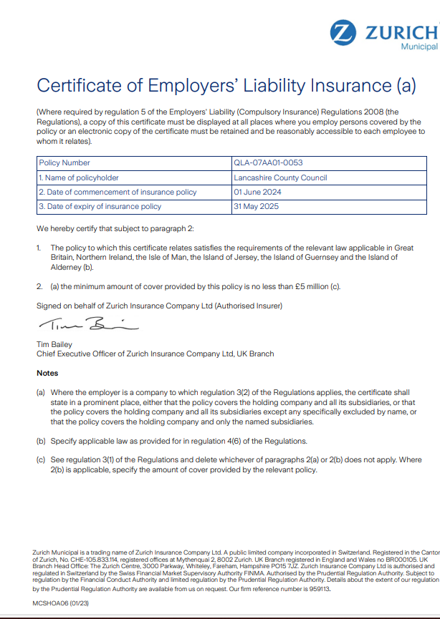
Site Sweep Form
W/B__________________________
Hazard |  | √ X
Fallen Branches
Broken / low Branches
Slippery areas
Flooding
Bogs
Brambles
Nettles
Thorns
Broken Glass
Needles
Litter
Vandalism
Intruders

Animal Faeces

Boundaries
Fences

Safety Equipment
-First Aid Kit
-Fire & Burns kit
Mobile phone/radio
-fully charged

 | Additional Information:
 | Date & Time
 | Signed
Holme Slack Community Primary School
Headteacher:  Mrs. M. Peck  Telephone:  01772 795257 |  | Manor House Lane  Preston  PR1 6HP
Dear Parents,
During the next term your child will be participating in weekly Forest School sessions. The sessions will take place in the new Forest School area next to school. This will be for 6 sessions initially.
Please ensure your child comes in the following clothing on the dates above:
- Outdoor shoes – Walking Boots/Wellingtons Recommended
- Warm socks - A warm waterproof jacket
- A jumper or fleece - A long sleeve T-Shirt
- Trousers - Waterproof over-trousers if possible
- Extra layer of clothing weather depending - Hat
- Gloves -Water bottle
The extra items can be brought in a bag and we will change before we go out into the woodland.
Please note these clothes and shoes will come back wet and dirty with mud.
If you are struggling to provide them with any of these items, please contact me. Your child will come home in their Forest School clothing.
During Forest School sessions, children are encouraged to work with others to carry out activities such as den/shelter building, team work, exploration, practical and creative skills.
If you would like to find out more about the forest school ethos, please visit:
www.forestschoolassociation.org/what-is-forest-scool/
I am sure that your child will make the most of this wonderful opportunity to learn new skills in the outdoor environment.
If you have any questions do not hesitate to contact me. Please return the reply slip below.
Yours sincerely,
Mrs H Lenz
Pastoral learning Mentor & Forest school Leader
I give permission for (Name)___________________________________________________________
to take part in all Forest School Sessions. I have read and taken note of what they need.
Parent/Carer Signature:____________________________Name:____________________________

