
My journey
Imagine you are going on a journey. You can travel anywhere you want!


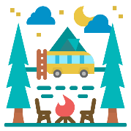



Picture
Where will you go? ________________________________________
________________________________________________________

How will you travel there? ___________________________________
________________________________________________________

Who will you go with? ______________________________________

How long will it take? _______________________________________

What will the journey be like? ________________________________
________________________________________________________
________________________________________________________

