Developing a pencil grip in EYFS
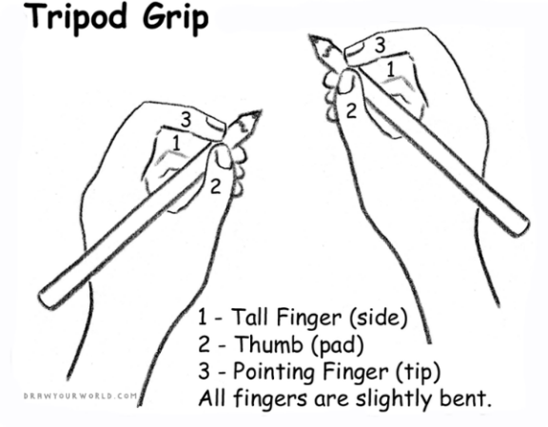

Developing a good pencil grip is relent upon developing your child’s fine motor skills. Here are some ideas to help with this at home:

- Encourage building with Lego and small bricks
- Activities which encourage using a pincer grip (picking up pom poms, sequins, coins etc)
- Threading beads
- Having fun with chalk, paint and chunky crayons
- Peeling stickers
- Kneeling, rolling and squashing playdough

Simple writing activities:
- Tracing
- Careful colouring
- Shopping lists
- Name writing
- Using stencils
- Drawing

