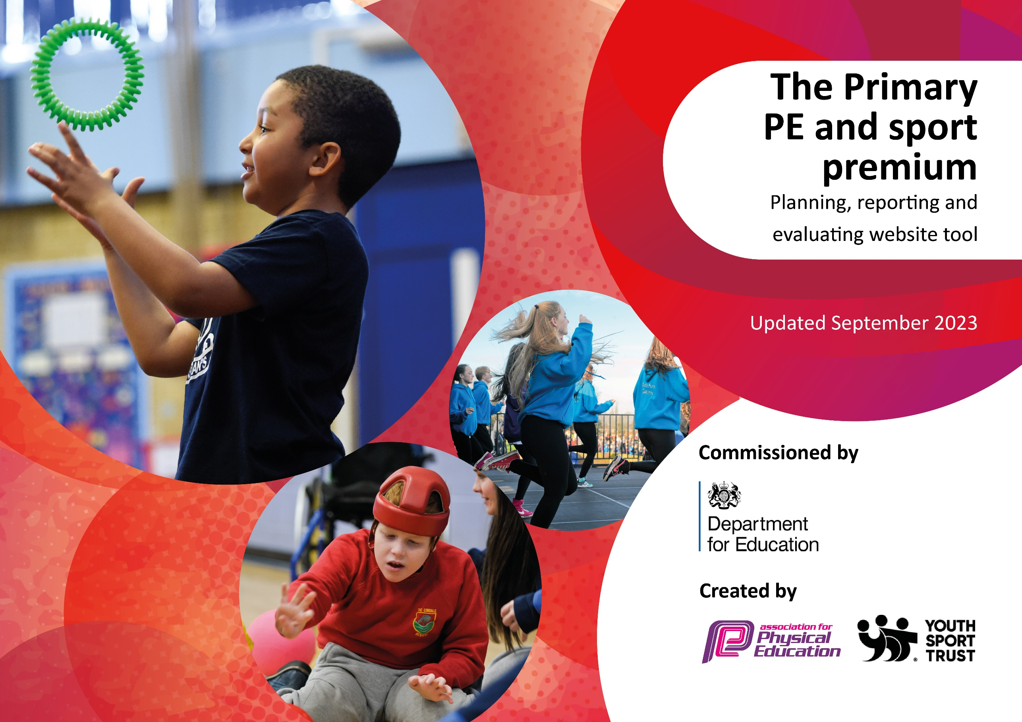

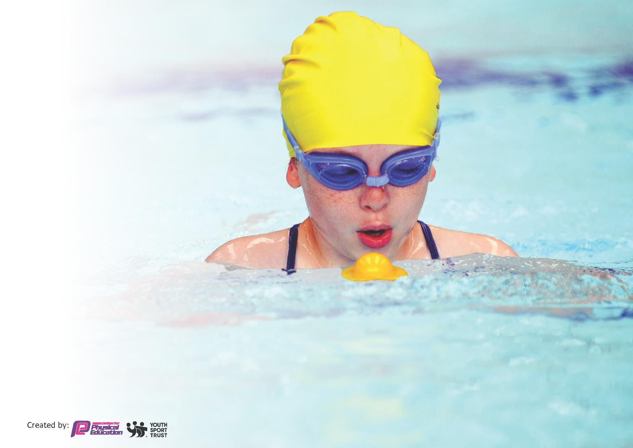
This template can be used for multiple purposes:
by:
- It enables schools to effectively plan their use of the Primary PE and sport premium
- It helps schools to meet the requirements (as set out in guidance) to publish information on their Primary PE and sport premium
- It will be an effective document to support Ofsted inspections enabling schools to evidence progress in Physical Education (PE) and evidence swimming attainment, which forms part of the PE National Curriculum. We would recommend schools consider
the Intent, Implementation and Impact of any spend, as examined within the Education Inspection Framework.

It is important that your grant is used effectively and based on school need.

Schools must use the funding to make additional and sustainable
improvements to the quality of the PE, School Sport and Physical Activity (PESSPA)
they offer. This means that you should use the Primary PE and sport premium to:

- Build capacity and capability within the school to ensure that improvements made now will benefit pupils joining the school in future years
- Develop or add to the PESSPA activities that your school already offers.

The Primary PE and sport premium should not be used to fund capital spend projects; the school’s core budget should fund these. Further detail on capital expenditure can be found in the updated Primary PE and sport premium guidance.

The Primary PE and sport premium guidance, outlines 5 key priorities that funding should be used towards. It is not

necessary that spending has to meet all the key priorities, you should select the priorities that you aim to use any funding towards.

Although completing this template is not a requirement for schools, schools are required to publish details of how they spend this funding. Schools must also outline what the impact this funding has had on pupils’ PE and sport participation and attainment and how any spending will be sustainable in the future. All funding must be spent by 31st July 2024.

The Department for Education has worked closely with the Association for Physical Education (afPE) and the Youth Sport Trust (YST) to develop this template and encourages schools to use it. This template is an effective way of meeting the reporting requirements of the Primary PE and sport premium.
Review of last year’s spend and key achievements (2022/2023)

We recommend you start by reflecting on the impact of current provision and reviewing your previous spend.

Activity/Action | Impact | Comments
Specialist coaches for dance and gymnastics.  Transport to and from events to allow more children to compete in competitions  Increase the statistics for swimming.  Sports coach to complete PE Specialism course  Increase participation in more sporting events | Upskilled all staff to teach dance and gymnastics and gave children who do not like competitive sports a chance to be more creative with their knowledge in PE.  Transport was a significant barrier last year so money was used for hire of a minibus. Additionally, after school clubs and curriculum delivery were all planned around the competitions.  Swimming is delivered to our younger children now. This has led to an increase the end of year percentage.  Upskill of our sports coach so that she is able to lead PE sessions at a high level to all year groups. The aim is to provide her with a strong knowledge of physical development and physical literacy.  Participation in sporting events have doubled in comparison to last year. Also, it has increased participation of the younger children in school. | All children enjoyed the session. Also, children who rarely enjoy sport found that this was a part of PE that they could be creative and take part in. Often becoming leaders and gaining confidence.  All our teams competed were successful in finishing within the top three in the majority of competitions over the year. Also, many more children were able to attend competitions which has developed the children’s sense of belonging.  Continue to make swimming a focus next year. Enable more children to confidently swim 25metres  Due to the sports coach delivering PE in all year groups she is able to see progression across the board and is able to upskill teaching staff with the knowledge gained. This means our PE lessons are tailored to the children but additionally staff receive up to date training in each PE session.  Children have attended a variety of different competitions and events leading them to gain confidence and resilience.

Key priorities and Planning
This planning template will allow schools to accurately plan their spending.

Action – what are you planning to do | Who does this action impact? | Key indicator to meet | Impacts and how sustainability will be achieved? | Cost linked to the action
Increasing Participation/ Active pupils  Year 6 children trained as playleaders to run activities for younger children during lunchtimes.  Election of Sports Council leaders across KS2 to increase pupil voice.  Increase of clubs for all age groups – every week night  CPD and improved teaching and learning  Complete whole teaching staff CPD to use resources to develop staff knowledge, confidence and high-quality teaching.  Renewal of PE Passport app – offering high quality lesson planning and assessment tool  Networks and subject leader support  PE Specialism course  Employment of PE Specialist  Dance and gymnastics specialist  Cricket Coach  Yoga Teacher  Raise profile of PE and sport  Interschool competitions  PESSPA events  Transport to sporting events | Whole school | Key indicator 2 -The engagement of all pupils in regular physical activity – the Chief Medical Officer guidelines recommend that all children and young people aged 5 to 18 engage in at least 60 minutes of physical activity per day, of which 30 minutes should be in  school.  Key indicator 4: Broader experience of a range of sports and activities offered to all pupils.  Key indicator 1- Increased confidence, knowledge and skills of all staff in teaching PE and sport.  Key indicator 2 -The engagement of all pupils in regular physical activity – the Chief Medical Officer guidelines recommend that all children and young people aged 5 to 18 engage in at least 60 minutes of physical activity per day, of which 30 minutes should be in school.  Key indicator 3: The profile of PE and sport is raised across the school as a tool for whole-school improvement  Key indicator 4: Broader experience of a range of sports and activities offered to all pupils.  Key indicator 3: The profile of PE and sport is raised across the school as a tool for whole-school improvement  Key indicator 4: Broader experience of a range of sports and activities offered to all pupils.  Key indicator 5: Increased participation in competitive sport. | 100% pupils meeting their daily physical activity goal, more pupils encouraged to take part in PE and Sport activities.  Year 6 pupils gained leadership skills when planning and running activities.  Whole staff participation in training and delivery of PE  All staff have access to lesson planning and assessment tool for progression of all children.  Subject leader up to date with current legislation and delivery of PE.  Sports coach is now up skilled in qualifications so progress is sustainable for all children.  PE specialist delivering all PE lessons / afterschool clubs. She will lead lessons to continue to upskill teaching staff.  Dance and gymnastics teacher continue to provide CPD for PE specialist and also offer lessons that are tailored for the needs of our children  Providing specialist coaching for PE specialist and tailored lessons for our children  Delivery of yoga to whole school  Increase to the amount of competitions entered and the number of children in attendance. This also allowed for some of younger children to take part in competitive events  Able to take more children to competitions so they are able to participate in a range of different sports | £0  £699  £85  £1250  £14,580  £382.50  £0  £0  £330  £100  £254.30

Key achievements 2023-2024
This template will be completed at the end of the academic year and will showcase the key achievements schools have made with their Primary PE and sport premium spending.

Activity/Action | Impact | Comments
Upskilling of the PE coach to PE Specialist  Variety of specialist events – yoga, dance, gymnastics and cricket  Ongoing training delivered to all teaching staff during PE lessons  Increased participation in sporting events. Enabling more children to attend events through the use of transportation company  Pupil voice through engagement of sports council and playleaders  Increase in swimming data. | PE specialist delivers all lessons across each class to improve development. Focus of FMS at EYFS to support core development of the child and progressing that through to Year 6.  Children take part in a range of sports and this enables our less willing to have a go in PE. Some of our stronger sporting children are often the ones who initially didn’t think sport included dance / yoga or gymnastics but can now see the benefit.  Through CPD and staff meeting all staff feel able to deliver PE.  Being able to take up to 14 children to events each time means many more children are able to participate in competitive events. Also having PE specialist not only deliver PE but attend sporting events gives the children a consistent approach to all events  Giving children a voice in what sports they like to do has led the curriculum to being tailored to our children. It also has led the types of clubs that are run afterschool  A rise in data means that more children have left school able to swim confidently. | The impact has been noted by teaching staff and the progress children have made in PE and in competitions. From going to sporting events to take part and ‘have a go’ we now have confident and adaptable children who take part in a variety of sports. Our teams are on the whole within the top 3 at events and able to show sportsmanship and resilience.  The range in sports as appealed to all our children and made them more confident and rounded individuals  The use of a PE specialist in all sessions means they have the continued support to progress children using resources such as STEP and PE Passport.  I will continue to build on attendance of sporting events but with the support of a dance and gymnastics coach next year I would like to enter more competitions in this area  I will continue to review this with our newly elected sports council team at the start of the academic year.  I have moved the swimming to Year 3 next year to enable children to swim from an early stage, in the hope that parents will start to attend swimming lessons. Also swimming data will be sent out to parents so that they know the levels of the children and the national standard. Also, we will be reviewing the use of top up vouchers to support families to prevent any barriers.

Swimming Data
Meeting National Curriculum requirements for swimming and water safety.
Priority should always be given to ensuring that pupils can perform safe self-rescue even if they do not fully meet the first two requirements of the National Curriculum programme of study

Question | Stats: | Further context  Relative to local challenges
What percentage of your current Year 6 cohort can swim competently, confidently and proficiently over a distance of at least 25 metres? | 54% | The increase of children able to swim at 25m is due to movement of age range attending the course. Initially children were in Year 5 when they went swimming but this was moved and the cohort attended whilst in Year 4. Due to financial strains for many of our families, children do not attend swimming lessons so the course may be the only time they have chance to learn how to swim. This will be continued to be assessed and support offered where viable.
What percentage of your current Year 6 cohort can use a range of strokes effectively [for example, front crawl, backstroke, and breaststroke]? | 54% | As above.

What percentage of your current Year 6 cohort are able to perform safe self-rescue in different water-based situations? | 27% | As above
If your schools swimming data is below national expectation, you can choose to use the Primary PE and sport premium to provide additional top-up sessions for those pupils that did not meet National Curriculum  requirements after the completion of core lessons. Have you done this? | Yes/No | This will be reviewed
Have you provided CPD to improve the knowledge and confidence of staff to be able to teach swimming and water safety? | Yes/No | Our PE Specialist attended the lessons and took part in teaching so is now more knowledgeable in this area of the curriculum. Additionally, training courses are being sought to continue to upskill her.

Signed off by:

Head Teacher: | 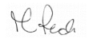
Subject Leader or the individual responsible for the Primary PE and sport premium: | Gemma Phillips – PE Lead
Governor: | K T Manogue – Chair of Governors
Date: | 29th July 2024

