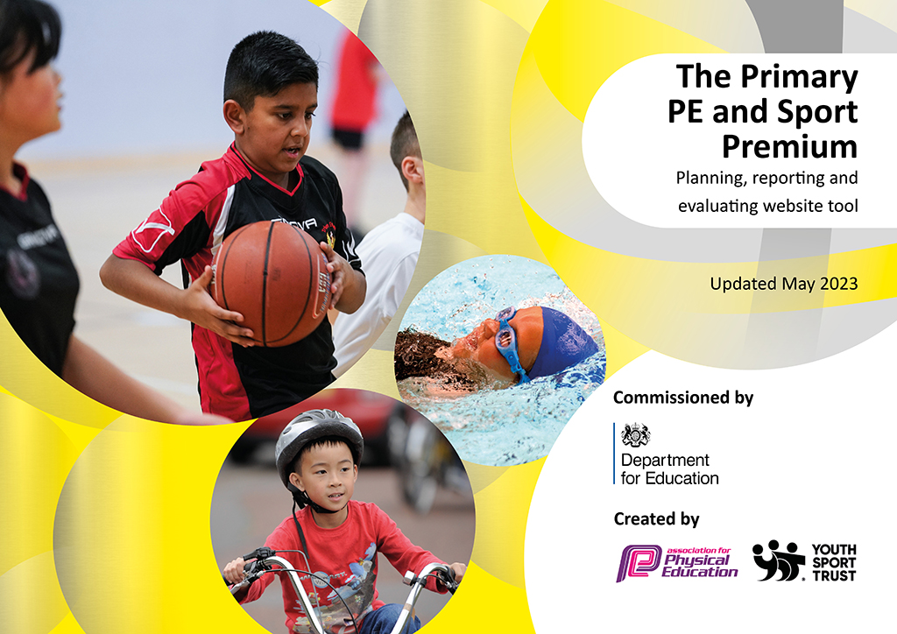
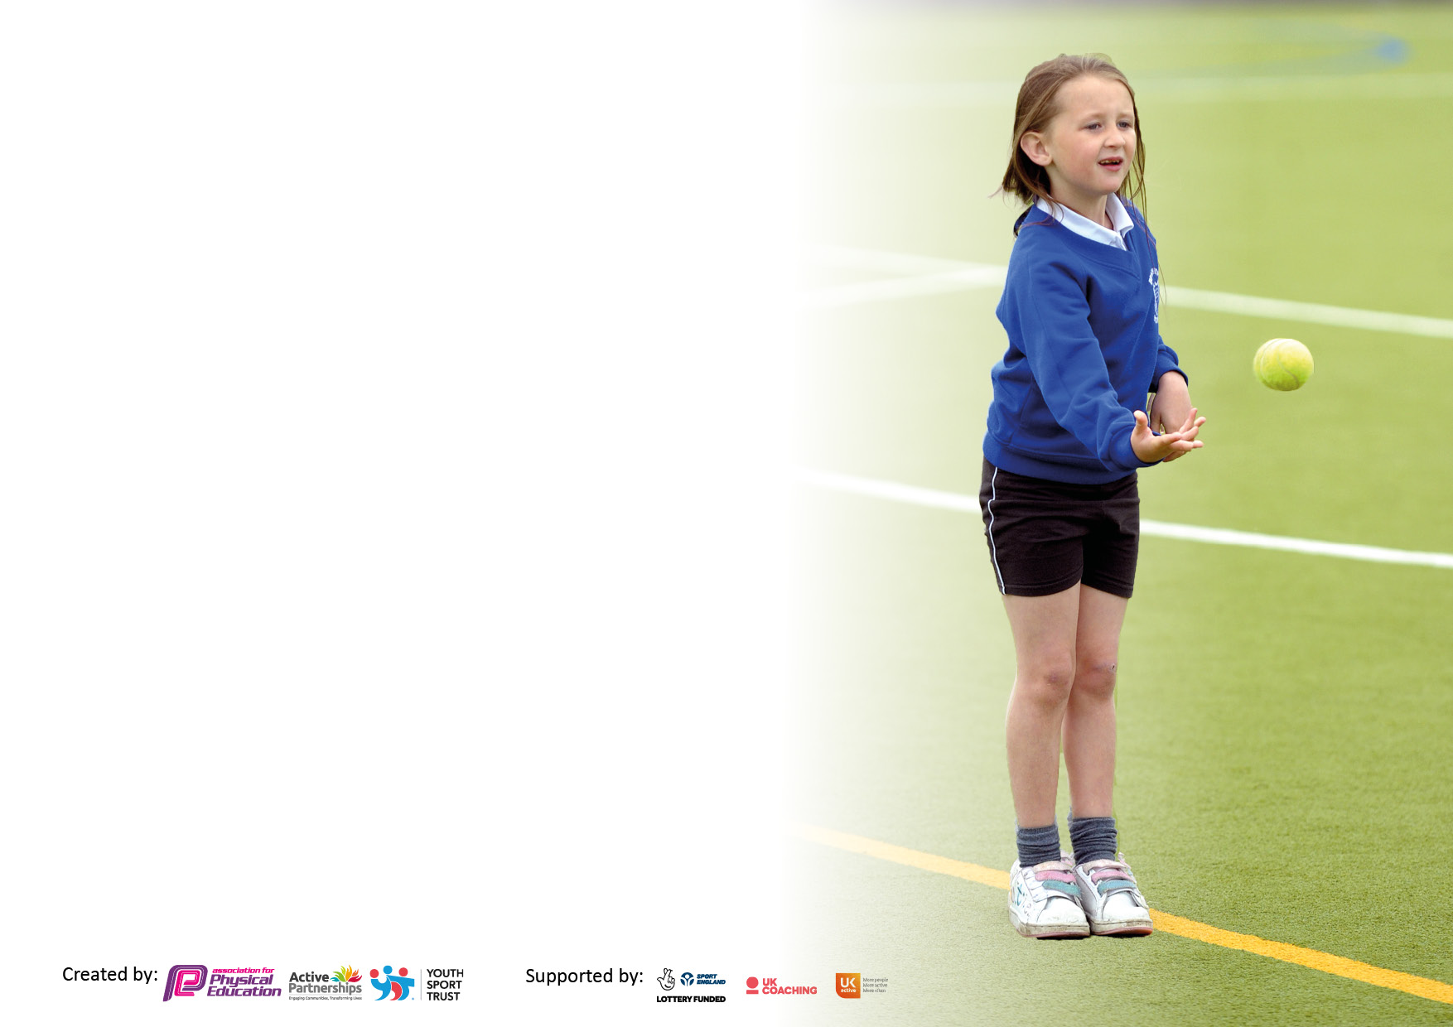

It is important that your grant is used effectively and based on school need. The Education Inspection Framework makes clear there will be a focus on ‘whether leaders and those responsible for governors all understand their respective roles and perform these in a way that enhances the effectiveness of the school’.

Under the Quality of Education Ofsted inspectors consider:
Intent - Curriculum design, coverage and appropriateness
Implementation - Curriculum delivery, Teaching (pedagogy) and Assessment
Impact - Attainment and progress

To assist schools with common transferable language this template has been developed to utilise the same three headings which should make your plans easily transferable between working documents.

Schools must use the funding to make additional and sustainable improvements to the quality of Physical Education, School Sport and Physical Activity (PESSPA) they offer. This means that you should use the Primary PE and sport premium to:

- Develop or add to the PESSPA activities that your school already offer
- Build capacity and capability within the school to ensure that improvements made now will benefit pupils joining the school in future years
- The Primary PE and sport premium should not be used to fund capital spend projects; the school’s budget should fund these.

Please visit gov.uk for the revised DfE guidance including the5keyindicatorsacrosswhichschoolsshoulddemonstrate an improvement. This document will helpyoutoreviewyourprovisionandtoreportyourspend.DfEencouragesschools to use this template as an effective way of meeting the reporting requirements of the Primary PE and Sport Premium.

We recommend you start by reflecting on the impact of current provision and reviewing the previous spend.

Schools are required to publish details of how they spend this funding, including any under-spend from 2021/2022, as well as on the impact it has on pupils’ PE and sport participation and attainment. The funding should be spent by 31st July but the DfE has stated that there will be no clawback of any unspent money so this can be carried forward into 2023/24.

We recommend regularly updating the table and publishing it on your website throughout the year. This evidences your ongoing self-evaluation of how you are using the funding to secure maximum, sustainable impact. Final copy must be posted on your website by the end of the academic year and no later than the 31st July 2023. To see an example of how to complete the table please click HERE.

Details with regard to funding
Please complete the table below.

Total amount carried over from 2021/22 | £0
Total amount allocated for 2021/22 | £0
How much (if any) do you intend to carry over from this total fund into 2022/23? | £0
Total amount allocated for 2022/23 | £0
Total amount of funding for 2022/23. Ideally should be spent and reported on by 31st July 2023. | £ 17690
Swimming Data
Please report on your Swimming Data below.

Meeting national curriculum requirements for swimming and water safety.

N.B. Complete this section to your best ability. For example you might have practised safe self-rescue techniques on dry land which you can then transfer to the pool when school swimming restarts.
Due to exceptional circumstances priority should be given to ensuring that pupils can perform safe self rescue even if they do not fully meet the first two requirements of the NC programme of study
What percentage of your current Year 6 cohort swim competently, confidently and proficiently over a distance of at least 25 metres?  N.B. Even though your pupils may swim in another year please report on their attainment on leaving primary school at the end of the summer term 2023.  Please see note above | 34%
What percentage of your current Year 6 cohort use a range of strokes effectively [for example, front crawl, backstroke and breaststroke]?  Please see note above | 34%
What percentage of your current Year 6 cohort perform safe self-rescue in different water-based situations? | 34%
Schools can choose to use the Primary PE and sport premium to provide additional provision for swimming but this must be for activity over and above the national curriculum requirements. Have you used it in this way? | Yes/No

Action Plan and Budget Tracking
Capture your intended annual spend against the 5 key indicators. Clarify the success criteria and evidence of impact that you intend to measure to evaluate for pupils today and for the future.

Academic Year: 2022/23 | Total fund allocated: | Date Updated:
Key indicator 1: The engagement of all pupils in regular physical activity – Chief Medical Officers guidelines recommend that primary school pupils undertake at least 30 minutes of physical activity a day in school |  |  |  | Percentage of total allocation:
 |  |  |  | %
Intent | Implementation |  | Impact
Your school focus should be clear what you want the pupils to know and be able to do and about  what they need to learn and to  consolidate through practice: | Make sure your actions to achieve are linked to your intentions: | Funding allocated: | Evidence of impact: what do pupils now know and what can they now do? What has changed?: | Sustainability and suggested next steps:
All children offered the opportunity to achieve 30 active minutes daily through physical activity at playtimes, lunchtimes and in curriculum sessions – PE and active Maths/English and the Daily Mile.  Employment of a specialist coach to teach PE in order to ensure a high quality of PE provision across school.  Sports Council established for pupil voice  To ensure playground equipment enables children to engage with a range of physical activities and equipment | To continue to use active Maths/English teaching tools – super movers etc. Daily mile/brain breaks  Continued employment and training of specialist coach to deliver lunchtime activities to target groups. To attend lunchtime activities/clubs – least active and behavioural  Children can speak to peers about what sports and events they want to happen in school.  Coloured baskets were implemented into playtimes so children can access a range of equipment. Improvement gross motor skills and social skills within sport (e.g. turn taking, resilience) | £0  (Sourced through fundraising)  £13722  Fund raised during last year for these resources | To continue to use active Maths/English teaching tools – super movers etc. Daily mile/brain breaks  Behavioural issues have reduced and less active children now involved in physical activity during break times.  Dinner time club organized and run by Sports Councilors. Pupil voice through school has led to move involvement in competitions  Development of resilience in all our children, children able to understand progression rather winning and losing. Children are much happier and content when playing in part of team. | To continue to implement in all classes.  Continue to implement interventions for behavioral issues and support medical (ADHD, dyspraxia etc)  To engage less active children using Sports Councilors as buddy system.  To continue to build on this using older children as role models across school
Key indicator 2: The profile of PESSPA being raised across the school as a tool for whole school improvement |  |  |  | Percentage of total allocation:
 |  |  |  | %
Intent | Implementation |  | Impact
Your school focus should be clear what you want the pupils to know and be able to do and about  what they need to learn and to  consolidate through practice: | Make sure your actions to achieve are linked to your intentions: | Funding allocated: | Evidence of impact: what do pupils now know and what can they now do? What has changed?: | Sustainability and suggested next steps:
To celebrate children’s sporting achievements that have taken place in school and out of school.  Free places for after-school clubs offered to all children.  Intra – school competitions each term  Increase motivation of pupils in PE & School Sport through visitors  To raise the sporting profile of our school through the School Games Mark | Sporting achievements celebrated during whole school assemblies. Children have the chance to share how the competition went and also celebrate medals and prizes won.  Afterschool clubs offered Monday – Thursday and delivered by PE specialist and sports coach based in school. All clubs are provided for free.  A variety of sports offered over each term to provide children with an overview of new sports but establish sportsmanship and team spirit.  Whole school quidditch event – Harry Potter themed and linked to World Book Day.  Bronze award received so aim for this year would be silver award | £0  £0  £0  £714  £0 | Children engaged in listening to other sports and awareness of sporting activities they can take part in. Children’s sporting achievements celebrated and given the opportunity to feel proud of their achievements.  All children are showing progression in core strength and knowledge of game sense across PE and extra-curricular clubs.  Every child from Reception to Year 6 took part in team events and earned team points for their house.  All children actively engaged and thoroughly enjoyed making links with how Quidditch s similar to a number of other sports.  Gold award achieved in the School Gamed Mark | Continue to pursue motivational and inspiration people visit school  Increase participation in PESSPA events and attend all meetings.

Key indicator 3: Increased confidence, knowledge and skills of all staff in teaching PE and sport |  |  |  | Percentage of total allocation:
 |  |  |  | %
Intent | Implementation |  | Impact
Your school focus should be clear | Make sure your actions to | Funding | Evidence of impact: what do | Sustainability and suggested
what you want the pupils to know | achieve are linked to your | allocated: | pupils now know and what | next steps:
and be able to do and about | intentions: |  | can they now do? What has
what they need to learn and to |  |  | changed?:
consolidate through practice:
CPD - Staff training termly so that all staff are equipped to teach PE for different learning needs and abilities. | Employment of a subject specialist coach to teach all year groups PE in order to raise confidence, knowledge and skills for teaching staff.  Subject Lead to attend Lancashire PESSPA meetings.  Subject Leader to attend PE briefings.  Subject lead and specialist coach to attend CPD sessions that are organized by Lancashire County Council  Resources purchased to aid the development of PE and sports. | £Accounted for above  £0  £0  £0  £177.96 | Teachers are more confident to plan stage appropriate activities for pupils and know how to differentiate these to meet learning needs for all pupils.  Training attended and feedback given to staff; staff understanding and aware of a variety of resources to be used for teaching and learning.  All pupils engaged and making good progress within PE lessons.  Up to date training in line with county council standards.  Resources available for staff to use | CPD - Staff training so that all staff are equipped to teach PE for different learning needs and abilities.
Key indicator 4: Broader experience of a range of sports and activities offered to all pupils |  |  |  | Percentage of total allocation:
Intent | Implementation |  | Impact
Your school focus should be clear | Make sure your actions to | Funding | Evidence of impact: what do | Sustainability and suggested
what you want the pupils to know | achieve are linked to your | allocated: | pupils now know and what | next steps:
and be able to do and about | intentions: |  | can they now do? What has
what they need to learn and to |  |  | changed?:
consolidate through practice:
Additional achievements:  To provide a range of sports. This will expose children to a wide variety of sports.  Specialist dance and gymnastics coach | Extra - curricular clubs have been put in place for younger children to focus on FMS whilst specialist teacher provides sport specific sessions to prepare for competition and progressive understanding of games sense and tactics  For all children to gain an in depth understanding of impact in other sports by benefits of core sessions. Engage and motivate the less enthusiastic children (don’t see these as a sport)  Year 5 and 6 residential to Waterpark | SportsCool  £1410  LJ Dance  £1297.50  £0 (funded as part of residential fees) | All children were filly prepared for competitions this year and have gained a secure understanding of game sense.  Younger children able to secure FMS  Children were excited to get involved. The were inspired by the teacher as she travelled the world competing and more focus and involvement particularly from boys was evident.  Children able to access and experience a broad range of sports: -Ghyll scrambling -High and Low ropes -Orienteering -Canoeing -Sailing -Kayaking -Hiking -Abseiling | Continue to use in next years sessions

Key indicator 5: Increased participation in competitive sport |  |  |  | Percentage of total allocation:
 |  |  |  | %
Intent | Implementation |  | Impact
Your school focus should be clear | Make sure your actions to | Funding | Evidence of impact: what do | Sustainability and suggested
what you want the pupils to know | achieve are linked to your | allocated: | pupils now know and what | next steps:
and be able to do and about | intentions: |  | can they now do? What has
what they need to learn and to |  |  | changed?:
consolidate through practice:
All children to have the opportunity and required skills to take part in competitive sports  Participation in local school competitions and leagues.  Whole school participation in Sports Day with competition focus | Funding participation in: -DB Sports -Sport School Partnership To take part in football and netball competitions and leagues  Children across the school have attended PESSPA events and local leagues. | £60  £300  £7.55 | Increased participation through entering competitions and leagues in football and netball. Also, friendly matches in both football and netball  Increased participation has led to Gold award and children keen to participate at events | Increase further participation – hire transport so more children able to attend

Signed off by
Head Teacher:
Date:
Subject Leader: | GPhillips
Date: | 27/6/23
Governor:
Date:

